The Social Side of Reflections

15 April 2008

Table of Contents
Background 1
Executive Summary 1
The Approach 1
The Implementation 1
The Server 1
The Wiki Engine 1
Forgoing Registration 1
Giving up on the MDL ID 1
Dealing with Compound Documents 1
The Workflow of Commenting 1
Tracking Comments 1
Going Public 1
The Response 1
Some Numbers 1
Some Context 1
Some Observations 1
Next Steps 1
Appendix 1

Background
The Minnesota Reflections site brings together a rich set of resources from institutions across the state. Each institution must not only provide images and documents, but also the metadata to describe these items. Providing even basic metadata is a challenge; full descriptions of each item are nearly impossible to generate. For a number of years planners of the Minnesota Digital Library Coalition (MDLC) have wondered whether it would not be possible to open up the description of items to public input. This project explores this "social side" of Minnesota Reflections, public input of item descriptions.

Executive Summary
The Social Side of Reflections (SSR) was built using the PmWiki engine on a server hosted by MINITEX. After some testing by the MDL SSR Advisory Committee, this commentary system was made available to the public on 14 January 2008 via a small link on the image and document pages of MDL Reflections. The system had captured 52 comments on about 50 items from 22 MDL collections by the end of March 2008.
- 23% of comments offered very personal insights, names of family, or stories behind the images.
- One third of the comments offered additional information about the item in question without revealing personal connections.
- 17% of the comments provided corrections to the description found in MDL.
- In 8% of the comments received, we also found a request for some kind of information or response.
- General comments about MDL or thanking us for providing a commentary tool comprised 9% of the feedback, and
- the final 13% were test postings likely by people trying to learn how the commentary system worked. Not a single spam comment was received during this period.
We converted about one of every 325 visits to Reflections into a visitor to the SSR. About one in every 5,300 visits to Reflections resulted in a comment on the Social Side. The SSR captured a respectable number of comments given the traffic on Reflections. Compared to comments on other sites like Flickr and YouTube, the quality of the feedback is very high.
The current simple system could be maintained indefinitely without much effort, though a decision to do so must still be made and a practice for responding to queries from users should be more carefully defined. If the Social Side of Reflections is to grow into a more sophisticated system that attracts more contributors and content, then there are at least two courses that should be pursued: the current SSR system should be massaged, improving its capabilities, and we should work to mainstream MDL content to a venue where it will be more readily found and commented upon.

The Approach
The first question we wanted to answer was whether the public had any interest in contributing descriptive information to the Minnesota Digital Library (MDL). Individual interactions the planners had had with members of the public at the state fair and in other settings led us to believe there were people out there who would invest time if the doors were open to such contributions. Some other Minnesota explorations of this kind of input, such as Hennepin County Library's Bookspace and Minneapolis Public Library's teen "make your own list," had already met with some success. The Social Side of Reflections (SSR) would be our first steps toward demonstrating this interest in the MDL community. At this stage we needed only a clear interface for quick annotation. We planned to keep it simple.
We proposed to use wiki technology as the basis of this simple annotation system. This wiki would be completely separate from the main MDL database and only linked to entries of that system through the use of common item identifiers. In other words, we would use the same image ids on the commentary wiki as Reflections used internally in its database. By keeping the commentary separate from the main database we would eliminate any potential security risks of a system open to the public. There would be no way for the commentary to impact the existing professionally populated database. A simple link would be provided from Reflections that moved the user to the commentary system and allowed them to add comments for the item they were inspecting.
The risks of building such a system were relatively low, both because it would build on already existing wiki technology and because it would be well isolated from the MDL's core systems.
Anyone in the world may have information about an MDL image that they would like to contribute. While the SSR wiki would be open to the world, we expected that the primary audience would be citizens of Minnesota. The system had to be designed for non-professional use, with simple instructions and quick rewards for contributions. The most important quick reward would be that a user's contribution became immediately visible in the SSR system.

The Implementation
Implementation of the SSR was accomplished primarily by the consultant, however a vital role was played by both the Digital Library Development Lab at the University of Minnesota and server administrators at MINITEX.

The Server
Meeting in early November 2007, the consultant, the lab, and staff of MINITEX determined that a server situated at MINITEX offered the best long-term value for the MDL. MINITEX offered to set up a Linux server running Apache, PHP, and MySQL. Later in the project MINITEX determined that the server was powerful enough to run other services for MINITEX alongside the MDL-SSR wiki, so it now hosts multiple services. We also determined that due to the choice of PmWiki for our wiki engine, we would not need MySQL for the MDL-SSR.
The consultant met with server administrators at MINITEX twice over the course of the project to keep them informed of configuration choices and the architectural implementation of the system.
The MDL also provided a host name for the new service. We decided it would be good to use a name distinct from the Reflections system so that we would not be locked into any deeper connections between the two systems. The hostname “views.mndigital.org” was pointed at the MDL-SSR server by the end of November.

The Wiki Engine
The consultant was already familiar with a PHP-based wiki engine called PmWiki and recommended this as the engine for the SSR project. Representatives of the lab and MINITEX concurred and we proceeded in this direction.
PmWiki provides a PHP platform for presenting web pages. While it is primarily a wiki engine, the system is highly configurable. In this case we did not intend to allow outside users any access to the actual wiki features of PmWiki. Instead, we installed a plugin called “CommentBoxPlus” which provided a more structured comment input facility for users. While users would never actually edit the wiki page, in fact their comments were being stored as additional text on a wiki page.
One goal of the project was to have as little impact on the lab’s staff as possible. The lab asked that we try to make the system work without requiring that any CONTENTdm code be written on their. PmWiki facilitated this by making it a simple matter to parse the referring site for inbound connections to the SSR. From that referrer we could tell whether connections were coming from Reflections and even which record in Reflections was the source of the connection. In this way, all lab staff had to do was create a single generic link to the SSR system, no per-item customization was required.
The PmWiki engine also provided a very simple mechanism for “skinning” or customizing the look of the system. Though the SSR was to be completely separate from Reflections itself, we wanted users to feel like they were still using Reflections when they used the SSR. We were able to create a skin for the SSR that successfully mimic the look and feel of the main Reflections site.

Forgoing Registration
When considering the array of social software out in the real world we realized that most (blogs, slashdot, wikipedia) do not require registration to participate as a commenter. If we required any sort of registration, it would probably limit our pool of participants.
One concern was that without user registration, we could not allow users to edit posts they had already posted. Yet these other social software tools (with the prominent exception of wikipedia) do not allow such reediting of comments already posted. Typically in a "comment" system, once a comment is posted the only alternative for the user to correct prior posting is to make a new posting. We thought that simple system would be good enough for this project. Remember, our goal was to encourage participation and keep the barriers low.
Even though we began the project assuming the SSR would implement user registration, we decided to forgo such registration. Given the way this simplified both the implementation task and the user interaction, we felt the departure was warranted.
The SSR did not require any user registration and did not allow regular users to edit any prior postings. Note that system administrators (and this could be anyone we designated, not just the consultant) could edit any and all comments left on the site.

Giving up on the MDL ID
Though we initially intended to use the MDL identifier as the link between records in the SSR and their counterparts in Reflections, we learned that the MDL ID has not been assigned reliably and could not perform this role. Some identifiers might not be unique and others did not conform to the structure we allowed for the identifier. Instead, we relied on the CONTENTdm record identifier (the collection and pointer, in CONTENTdm-speak) for this purpose.
The MDL ID was to be a unique string composed of a lowercase alpha prefix (representing scanning center or site) plus a set of digits (representing, more or less, each item) plus an optional alpha suffix (representing the multiple scans required to digitize some items, back and front of postcards, for example). Some examples of appropriate MDL IDs would be: umn16595a, umn16617, irr00517, shm001558, mhs02721.
Jason Roy informed us that some scanning sites might not have kept IDs unique. This would make the MDL ID unusable as a key between the two systems. John Butler also pointed out that some MDL IDs in existing records do not conform to the structure outlined above (see “ms.gn00001.1.d1” as one example). This means that the SSR could not count on their structure to derive proper links.
As a result, we chose to use the CONTENTdm collection alias and pointer (such as "swede-50" with the hyphen being used to separate the two) as the key to reference between systems. We expected to at least keep the MDL ID somewhere in the SSR data for future reference, but even this was not possible given our efforts to minimize impact on the main Reflections system.
Note, to use the collection alias and pointer as a key meant we had to enforce some rules on the collection aliases used in Reflections. Roy stated that "no slashes, dashes, dots or caps, now or ever" would be an enforceable constraint on those collection aliases. That allowed the CONTENTdm collection and pointer to serve as the link between the two systems. However, if the Reflections system ever has to be rebuilt and reindexed from the ground up, or moves off the CONTENTdm system, these pointers could change, breaking the link between the two systems.

Dealing with Compound Documents
Some Reflections content is stored in what CONTENTdm considers a “compound document.” These compound documents consist of many images which comprise a single whole. For example, each page of a journal is a single image, but the journal as a whole is considered a compound document. Many maps and letters also turn out to be compound documents in Reflections.
We decided that for the purposes of the SSR, comments on any image within a compound document would be treated as comments on the compound document as a whole. This means that any user comment on any part of a compound document would share a single commentary page with all comments about that compound document.
We learned that CONTENTdm does assign an identifier (a collection and pointer) to the whole document which is distinct from those assigned to the constituent parts. We also learned the MDL had not been assigning MDL IDs to the document as a whole, yet another reason to give up on the MDL ID as a key between the two systems.

The Workflow of Commenting
The most complex part of the implementation was choreographing the dance that servers and browsers go through when a user clicks on the “comment” button in Reflections. The basic sequence of events after a user clicks the “comment on” button in CONTENTdm is shown in this diagram.
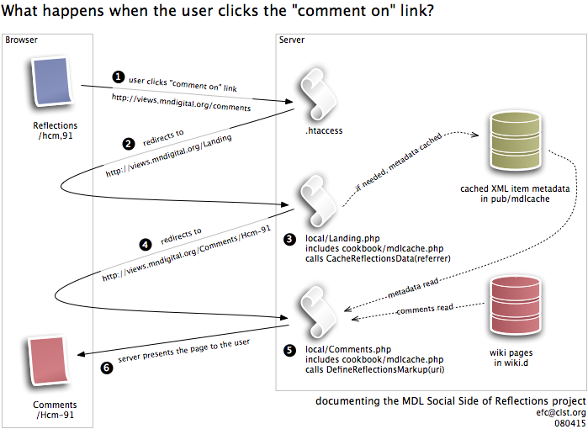
As already stated, a primary goal of the project was to keep things simple for the CONTENTdm side of Reflections. This is reflected in the nature of the link included on CONTENTdm pages to refer to the SSR. Any page on the CONTENTdm side can simply include a link to “http://views.mndigital.org/comments” in order to connect to the SSR. The SSR is responsible for determining what content is being discussed by parsing (or unraveling) the referrer information passed along in the HTTP header. Note, that meant that simply navigating to this comment URL would not result in a connection to any particular comments on the SSR. The only meaningful way to access the SSR would be by clicking on such a comment link embedded on an item or document record in Reflections.
Step 1: The SSR Redirects
In order to stay flexible on the SSR side, we did not put any actual scripts or pages behind the comments address. Instead we created an HTTP redirect via the “.htaccess” file on the server. This redirect pointed the user's browser over to a group of wiki pages called “Landing.”
Step 2: Landing at the Wiki
The Landing group on the wiki had a configuration script (see "pmwiki/local/Landing.php" on the server) which passed the HTTP referrer (which should be a Reflections item or document page) on to the function CacheReflectionsData of the script "pmwiki/cookbook/mdlcache.php".
Step 3: Cache Reflections Data
This function parsed the referrer and checked to see if the SSR had already cached metadata about the item in question. If not, then it took care of retrieving, parsing, and saving that metadata from Reflections, and returned a wiki page name in which comments on the item in question were to be stored. Note, if we have already had cached the Reflections metadata, then this function had very little work to do.
This function is where the greatest dependencies on CONTENTdm are to be found. If changes are made to the structure of the item views of records in the CONTENTdm side of Reflections, then this function should definitely be retested. In order to parse out information like the title of the item it does some pretty ugly pattern matching. If we ever do make significant changes to the cacheing code, it would probably be a good idea to invalidate the cache. To do this, simply delete all the directories inside the "pmwiki/pub/mdlcache" directory on the server. This function will recreate these cache files as needed. In order to make these files more comprehensible to future maintainers, these cache files were formated as simple XML files.
Step 4: Going to the Comments Page
Once the caching of metadata was complete, the Landing script then redirected the users browser to the appropriate comments page.
Step 5: Gathering parts of the Comments Page
The "pmwiki/local/Comments.php" configuration script for the Comments group of pages used the same "pmwiki/cookbook/mdlcache.php" script to pull the item metadata out of the cache. This time the DefineReflectionsMarkup function was called with the URI, which now included the collection and pointer for this item. DefineReflectionsMarkup built a set of global variables for use both in the SSR skin's template file and in the markup of certain pages on the wiki itself. This made it possible for the “/Comments/GroupHeader” page to include some general markup (like a copy of the image in question) that ended up representing individual items when invoked.
The wiki engine pulled any prior content for this page (essentially any prior comments) from the "pmwiki/wiki.d" directory.
Step 6: Present the Comments Page to the User
The user's browser finally rendered the appropriate comment page. This page included a form for leaving further comments.

Tracking Comments
We wanted to be able to track the comments being left on the system so that we could both assess the effectiveness of the system and make sure no inappropriate comments were being left on the SSR. We became especially sensitive to the potential for vandalism when we decided to forgo user registration, though we did include a minimal spam deterrent by requiring that users retype a code number before their comment would be accepted by the system. Two methods of tracking comments were implemented: email and RSS.
Email tracking was accomplished through the configuration of PmWiki. We essentially told PmWiki to send messages to the consultant whenever it noticed that new content had been added to or changed on the SSR site. This method resulted in an email to the consultant within twenty minutes of any content being changed. Note that other MDL staff could be included in this mailing, though none chose to participate during the project period.
RSS tracking was accomplished by using an RSS news reader to subscribe to a page on the wiki that changes whenever content is added or changed. New comments would trigger such a change. The address for the RSS feed from the SSR was “http://snurl.com/mdlfeed” or “http://tempest.minitex.umn.edu/Comments/RecentChanges?action=rss”.
Some desire was expressed by MDL participants for a mechanism to facilitate RSS tracking of comments left for particular participant institutions. Providing such an RSS feed would be possible in the next version of PmWiki, but an upgrade of the PmWiki engine was not part of this project. It would also be possible to provide email updates particular to individual CONTENTdm collections through the configuration of the “Comments” group of PmWiki pages, though such configuration was not attempted during this project.

Going Public
We did allow the MDL-SSR Advisory Committee to review the system before we launched it for public use. The Advisory Committee worked though a set of “homework” assignments developed by the consultant in order to identify weaknesses in the system. A number of changes were made to the SSR based on committee feedback.
On 14 January 2008 we posted a note to the MDL Steering Committee announcing the availability of the Social Side of Reflections. This note was later picked up by MINITEX and distributed to its statewide constituency.
We made the Social Side of Reflections available to the public on 14 January 2008 by simply revealing a small link in the “navbar” of Reflections. Our first comment was received from Europe just hours after the link was made available.
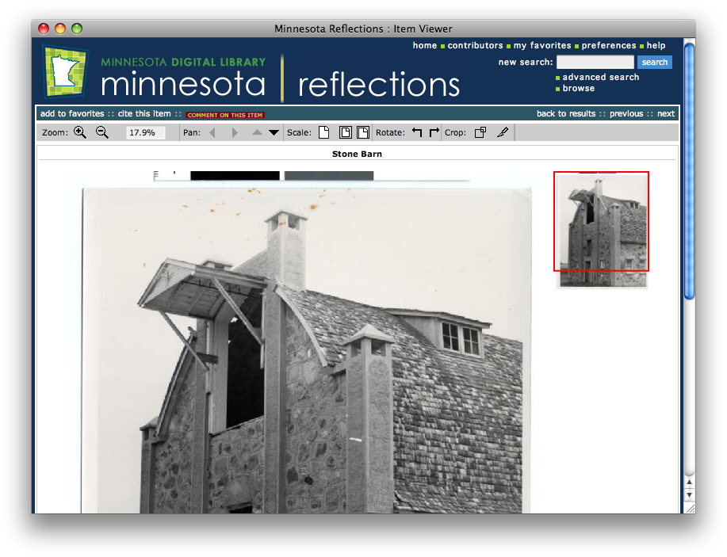
Notice the yellow text on a red “button” in the green stripe above the image? It was quite small and was even harder to discern on older hardware with smaller monitors. Here is a close-up of the relevant part of the window above.

While small, it was very bright. This was the link to the Social Side of Reflections. When a user clicked on that link they arrived at the commentary page.
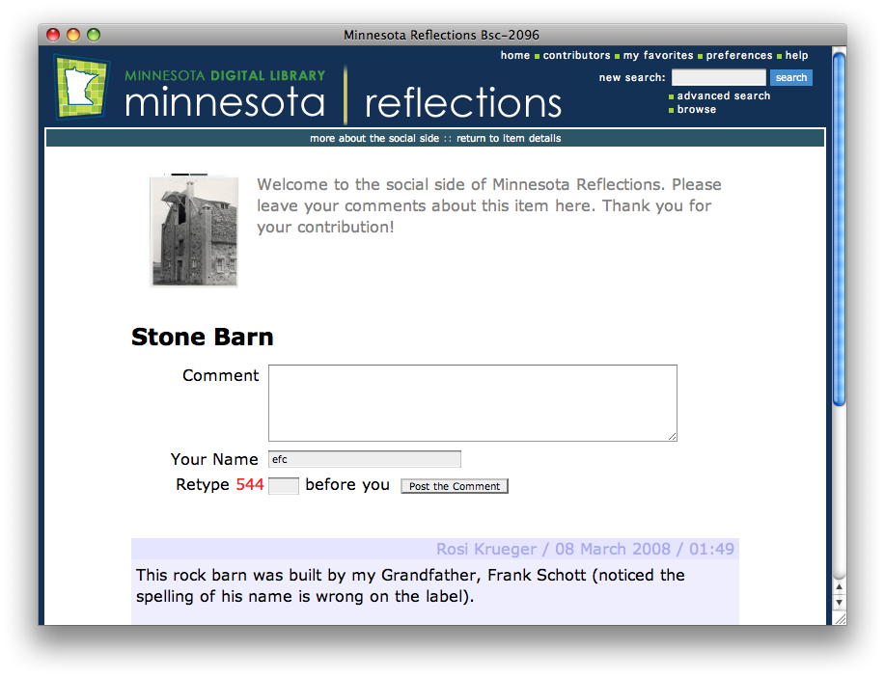
This page was meant to look and feel just like the rest of Minnesota Reflections, but it was actually a completely separate system on a different server in a different building managed by different staff. The only reason it “felt” the same is that it has been designed to use the same stylesheet and layout as the regular Reflections pages. The Advisory Committee helped draft the welcoming text and determined that the invitation to add a comment should be put above any pre-existing comments.
To enter a comment, the user would just type text into the box marked “Comment”, put their name into “Your Name”, and retype the numeric code. The resulting comment would be posted on the page and look something like this.
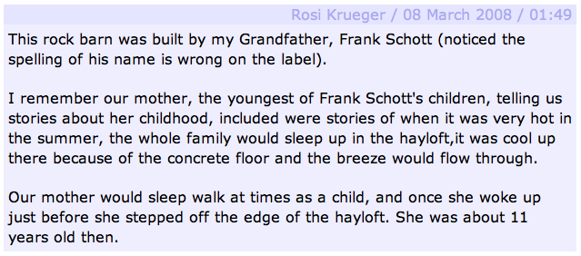
This particular comment is a fine example of the sort of comments that have been left in the Social Side of Reflections. In this case a very personal story combined with a gentle correction to our metadata.

The Response
We had two concerns as we began this project: one was that nobody would find our comments section and leave comments, the other was that vandals would find our comments section and leave junk. Happily neither of these scenarios became reality. The comments received, aside from a few probing “test” messages, were all constructive. Many of the comments were highly personal and illuminated an emotional side of the Minnesota Digital Library familiar to those who work closely with Minnesota Reflections, but otherwise invisible. Still, the overall response to the Social Side of Reflections remains underwhelming, with an average of well under one comment per day being added to the site. Since the number of comments is still quite manageable, a full listing of the comments can be found in the Appendix.

Some Numbers
The SSR went public on 14 January 2008 and received 52 comments on 50 items from 39 authors by the end of our evaluation on 30 March 2008.
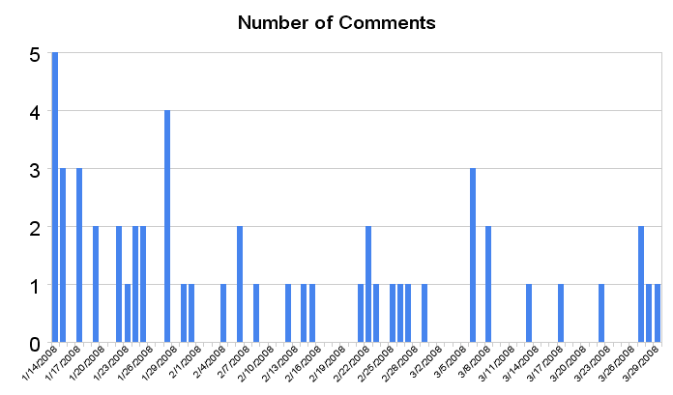
Most of the comments were received during the day, but a significant number were contributed during the evening hours (this chart uses a 24 hour Central time zone clock).
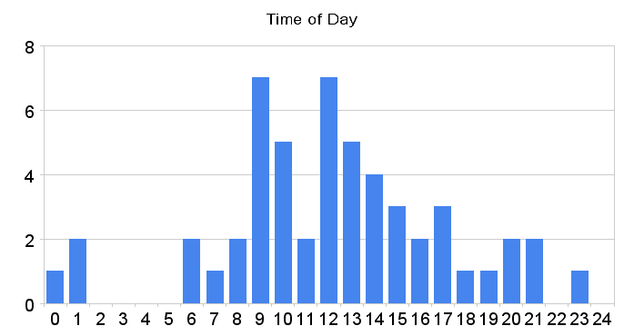
The comments referenced items in 23 collections, though the Northeast Minnesota Historical Center (NEHMC) collection generated by far the greatest feedback.
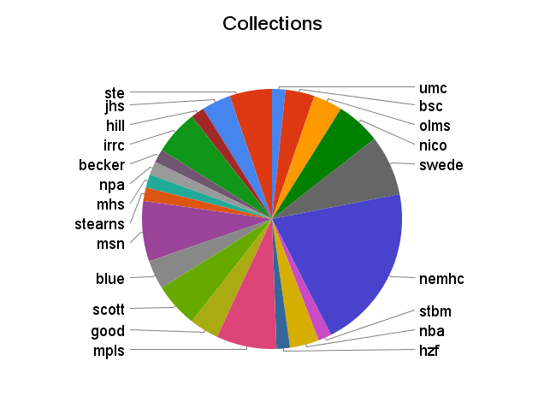
Most authors only left a single comment, but we had a few repeat visitors including some familiar names. It is interesting to note that this list of authors is not at all normalized. Even though we put no checks on what was entered for an author’s name, most users entered their whole name with standard capitalization. This is an indication that these authors were not seeking any sort of privacy: they wanted their stories and contributions known and were willing to stand behind them. Some of the names have been cut off in the representation below.
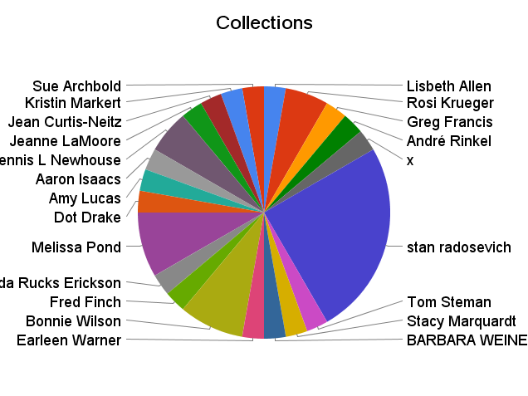
As part of an analysis of the comments seven categories were created and each comment was classified in the category that was most representative of it’s content.
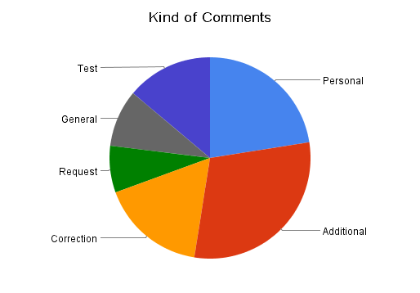
Personal stories were a fixture of the commentary. 23% of comments offered very personal insights, names of family, or stories behind the images. One third of the comments offered additional information about the item in question without revealing personal connections. Usually this was geographical context or stories about historical events involving the subject of the image. 17% of the comments provided corrections to the description found in MDL, often spelling corrections or notes on dates and such. In 8% of the comments received we also found a request for some kind of information or response. Given the structure of the SSR, there was very little we could do to actually respond unless the user put some kind of contact information into the comment itself. General comments about MDL or thanking us for providing a commentary tool comprised 9% of the feedback, and the final 13% were test postings likely by people trying to learn how the commentary system worked. Our seventh category was “spam” or vandalism, and it was very interesting to see that even though we only employed minimal protections against such abuse, we had not a single instance of it during the project period (though three mild and manual spam messages did arrive by 15 April 2008 when this report was drafted).

Some Context
There was quite a bit of activity on the SSR server that did not result in comments being generated. Excluding visits from web crawlers, there were about 12 contacts per day to comment pages on the SSR. These visits were to over 192 individual item comment pages. Since only 50 items actually received comments, it is clear that users only actually left a comment about 25% of the time they visited the comment page. Similarly, users considered commenting on items in 54 collections but actually left comments on items in only 22 collections.
A review of Reflections statistics for the period of the SSR project reveals that Reflections items and documents were visited approximately 278,000 times during this period. This means that we converted about one of every 325 visits to Reflections into a visitor of the SSR. About one in every 5,300 visits to Reflections resulted in a comment on the Social Side.
How does this compare with other sites on the net? That is remarkably hard to say and may be worth further research. A quick survey of mainstream sites (Amazon, Flickr, Google Video, and YouTube) that allow comments or reviews did not provide any good comparisons. The only site that made both viewing and commenting statistics readily available was YouTube. A hasty and survey of the top 10 most viewed YouTube videos showed that they generated an average one comment for every 871 views. It should be noted that YouTube only counts a “view” when a video is watched in its entirety, while the Reflections statistics I used would have included many “bounce” viewings where someone popped in and out realizing quickly the item was not what they needed or just running across it as they paged through a result set. Also, the “quality” of comments on YouTube is nothing like the quality of comments we received.

Some Observations
All in all, it appears that the SSR captured a respectable number of comments given the traffic on Reflections. Compared to comments on other sites like Flickr and YouTube, the quality of the feedback is very high. Most comments convey personal stories or additional contextual information that do help explain the images. A significant portion of the comments provide corrections of our metadata. Many of these comments were verified as correct and fixed in our metadata, though the limited and voluntary nature of staffing for MDL makes follow-through on this task difficult.
The comments pages were abandoned about three times as often as they were utilized. That’s not a bad thing, but it is worth noting. Most likely people were just checking to see what comments there were. This might lead us to try to incorporate the comments into the main item record somehow. Or perhaps we should simply raise a flag on the main record that indicates that there are comments, similar to the way blogs usually distinguish between adding the first comment and adding further comments.
Once the system was set up, the SSR took very little attention to run. The consultant read every comment that arrived to ensure no spam was sneaking in, and every once in a while checked with MDL staff to make sure a particular request got some response. All in all the current “keep it simple” system could be maintained indefinitely without much effort.
The tone of comments was very positive. A few of the corrections vented a bit of frustration about the misrepresentation of certain names, but in general people seemed genuinely thankful that such a tool was present and eager to share their insight. Even if the system does not become any more sophisticated, it can serve as a valve for expression and a net to capture this kind of input for future endeavors of the MDL.

Next Steps
A decision needs to be made about whether the system, even in its current state, will be maintained. If so, the consultant should meet with the MINITEX staff maintaining the system to pass along any remaining tips on how to take care of the system.
The MDL should make sure it has a standard plan of action for coping with “request” and “correction” comments. The current system does not allow a direct email response (since we don’t gather the contributors email address), but it does allow for MDL and participating staff to leave comments answering questions asked in earlier comments. If a suggested correction is not acted on, then some sort of explanation of why the MDL data remains as it is might be in order. If a suggestion does lead to a correction in the MDL data (and many of the comments during the project period did lead to such corrections), then a brief thank you would be reasonable as a follow-on comment. Over the long term, enthusiasm for participating in a community of care around something like MDL Reflections is built upon the trust that contributors have that their effort makes a real difference. The MDL should consider how it can build that trust.
If the Social Side of Reflections is to grow into a more sophisticated system that attracts more contributors and content then there are at least two courses that can be pursued. We can massage the current SSR system by integrating the commentary more closely with the Reflections database, for example allowing cross-searching, and providing a greater variety of commentary mechanisms, for example tying the commentary closely to the steve-based tagging (see http://www.steve.museum, we did get some user feedback requesting tagging). This would maintain the control MDLC has over the content of the commentary but provide for some growth in the way we use the data. Or we could push the commentary out into the "mainstream" of the web's social networks by putting versions of our images on a major image site and encouraging commentary there. This would make it much more likely that the masses would stumble upon MDL content and be inspired to leave their ideas attached. By careful design of our use of the mainstream site, we could also turn each posted image into a conduit of users back to the institutions which hold those images. Some combination of the two options is also possible. For example, we might decide to do some massaging while at the same time committing a couple collections of MDL to exploring the mainstream path.
The MDL should massage the SSR and improve the Social Side of Reflections as a standalone system by pursing the following goals:
• Improve the RSS feeds so that individual institutions can more easily follow the comments made about their own collections. The PmWiki engine does have the capacity for this in its current beta versions, but moving to one of these beta versions or to a later stable version based on them will require some technical assistance and attention.
• The comments button is really quite small and unassuming. The MDL should consider redesigning this element to be a bit more noticeable and attractive.
• Similarly the MDL should do more to publicize Reflections and the Social Side of Reflections so that more people came to the site and discovered the riches within.
• Even without adding user registration, the MDL might be able to engage in conversations with some contributors if a “contact us” email button were added to the comments page. This requires no new technical infrastructure, but would provide contributors with a way of sharing requests using a tool (email) that provides the MDL with a return address.
• The MDL should provide a search of the SSR along with Reflections itself. The MDL could explore various methods of providing such unified searching. Note, PmWiki does provide a search mechanism that would allow us to easily add searching to the SSR, but it was thought that doing so might confuse users given that the Reflections interface, which we use for the SSR as well, already has a search box present that searches Reflections data.
• Since users seem to pop over to the SSR just to see if there are any comments present, the MDL should make that information more available from Reflections itself. The graphic used for the comments button in Reflections could be retrieved from the SSR. This would allow the SSR to dynamically present a button that either indicates comments are already present or not. Such a solution would require some technical work on the SSR, but could be accomplished with virtually no work on the Reflections side.
• There is a real danger in the fact that the MDL ID was unusable for this project. The MDL should clarify practice with regard to its identifier and clean up what mistakes have been made. The MDL ID should be the key to data in projects like this, and the MDL’s reliance on the CONTENTdm collection and pointer leaves the data more vulnerable to indexing problems with the current system and migration problems should it ever want to change the system behind reflections.
• An XML-based item level page should be developed with the CONTENTdm API so that systems like the SSR are not vulnerable to format changes in the human-readable item pages.
• Staff should make it a practice to always add a comment thanking or at least acknowledging users who contribute metadata corrections. If the correction was implemented, this should be acknowledged as well. This helps motivate contributors.
Moving MDL Reflections images into the mainstream so that they attract greater interest and feedback would be a significant challenge that could really enhance the “social side” of the MDL effort. These images could be put where people already gather. Pursuing this mainstream course would include the following goals:
• The MDL leadership team should engage in conversations with MDL participants to help them understand the value of distributing MDL content beyond the confines of Reflections.
• The MDL should contact those responsible for efforts like the Library of Congress or National Library of Australia collections on Flickr to find out how to work with a mainstream content provider while retaining some connections of the material to an MDL presence.
• A workflow for moving material over to the mainstream site on a regular basis should be developed.
The MDL has demonstrated that its users are capable of creating a new and very personal layer of description for Reflections content. Reflections users are remarkably responsible in the way they approach the task of contributing this content. They are valuable partners in building a digital library for Minnesota. This small and purposefully simple pilot shows that there is great potential in the pursuit of broader participation in the description of MDL content. The challenge before the MDL is realizing this potential.

Appendix
These are the comments received on the Social Side of Reflections between 14 January and 30 March 2008. Some comments from the consultant and other that said simply “test” have been removed from this list.
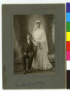 | scott-126: I believe this is Charles C. Kopp and Susan Pollard, married 28 June 1904 in Shakopee (at ages 30 and 29 respectively).
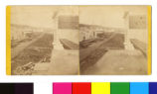 | nemhc-1404: This view is looking east. Pic is from a building on the lower side of Superior St (about 110-112W Sup St)
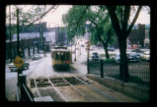 | msn-762: I live in the Selby-Summit neighborhood; Grew up in the Rondo neighborhood. I took the Selby-Lake streetcar through this tunnel many, many times. What a great ride! Memories of those times are treasured.
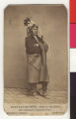 | nico-1020: Corrupted identification or spelling of Anishinaabe leader Bug-O-Nay-Ge-Shig/Bug-o-Nay-Geeshig/Bug-o-na-ghe-zhisk?
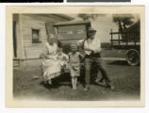 | nba-92: I was just surfing the net and put in my great grandfathers name. what a surprise to see the pictures and info. i sent the link to my mom as she is pictured as an infant in one of the pictures. so fun. she was thrilled. i am going to see if i can get reproductions of the pictures.
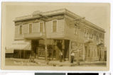 | nba-42: Is there a way I can get a copy of this photo? this is my grandfather's parents store (Alex was my Great Grandfather) xxx@xxx.net Thank you, Stacy Marquardt
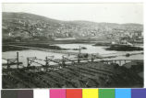 | nemhc-1561: These are the Northwestern Coal docks, but they are northeast of the grain elevators B,C,D on Rices Point; the structure in the water at the right center of the picture are the Kelly Island Lime docks, behind it to the right is the first Duluth Boat Club house on the water front between 6-7AveW, behind that is the Spaulding Hotel on 5AveW & Superior st
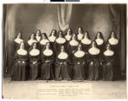 | ssc-62: This beautiful image reminds me of the Sound of Music, which portrays the relationships between nuns and novices with such warmth and care. This relationship attracted my wife to the Catholic church.
 | ssc-62: This is a favorite photo for me, personally and professionally. I use it to highlight the zoom feature in the collection. I also use it to discuss metadata. But, I love the face on the sister in the middle of the front row and I love to think about what the sisters did afte the image was made and if any of them did not continue on to take final vows.
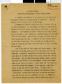 | olms-1071: I am amazed at the hardships endured by this pioneer mother. I wish I knew more about her.
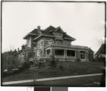 | nemhc-1378: NewsTrib 02-23-08 New residence of Charles A Duncan, under construction 22aveE 2nd . . building is of vitrified brick trimmed with Illinois marble and red tiling for the roof . . first floor finished in hard wood and floors above in enamel . . there are 22 rooms . . presently under roof . . completed in July . . Bray & Nystrom, architectsHerald 10-24-08 MrMrs Charles Duncan and family moved into their new house. Herald 01-07-10 MrMrs Charles Duncan issued invitations for wedding of dtr Miss Mabel Duncan to Jessie Bradley . . at home of brideâ€™s parents 2215 E 2nd on Jun 19.Herald 11-18-10 Reception . . Mrs Charles A Duncan 2215 E 2nd . . engagement of dtr Miss Grace Duncan to Norman McLeaod announced.11Polk Directory pg 371 Duncan, Chas A sectreas Duncan Brewer Lumber; pres Great Northern Power, res 2215 E 2ndHerald 06-12-20 Social event of the week will be the marriage of Miss Elsa (pic) Zachow, dtr MrMrs CJ Zachow 2031 E 6th and Russell C Duncan, son MrMrs CA Duncan 2215 E 2nd.Herald 07-14-24 Pic Obit CA Duncan 65, 2215 E 2nd . . Sec-Treas of Duncan Brewer Lumber . . to Duluth 44yr ago . . wife . . 3dtr, 2sons . . Mrs ND McLeod, Mrs JA Bradley, David C and Russell C of Duluth.
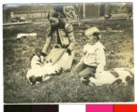 | scott-125: poor cat only has ears and a tail! More cat photos on MDL!
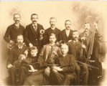 | ste-998: What a delight to see my great-grandfather Frank Wilcox in the Hancock Orchestra! Thank you.
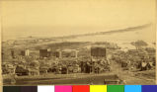 | nemhc-1482: Picture dates between March&May 1889 because of the absence of the Grand Opera bldg & ruins (Herald Mar 18,1889) and the appearance of its replacement Phoenix bldg walls up to the 2nd story (Herald May 23, 1889)at NE cor 4AveW & Superior St. Also on NW cor the Bayview hotel is gone, process of demolition (Herald Feb 17, 1889) and derrick used in building of its replacemnt Palladio Bldg hasn't appreared (Tribune May 31, 1889)
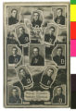 | nemhc-1853: Pitcher George "Hooks" Dauss would go on to pitch for the Detroit Tigers from 1912-1926. Pitcher Dan "Rube" Marion would go on to pitch for two years (1914-1915) in the Federal League for the Brooklyn Tip-Tops. There are two Major League players named Darby O'Brien but the person pictured is neither one.
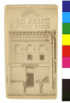 | nemhc-2049: Bldg located 219 W Sup. ("Splendid glass plate front two panes 90x106 being put in Willis' new store." Wkly Tribune 2-10-1882) ("Boston One Price Clothing House WG Willis ns sup 2-3AveW" Polk Directory 1883) ("Boston One Price Clothing WG Willis 219 W Sup" Polk Directory 1886)
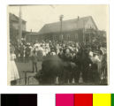 | nemhc-1894: The Urania Hall is now the Range Print Shop & Gifts and from this side still retains much of its original looks. Over time it lost the front varanda, but still has most of the original siding, chimney and some interior. The 4th is still a big hit here in Eveleth!
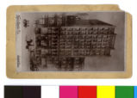 | nemhc-1395: I think that this is the Torrey Bldg, not Alworth.
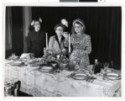 | jhs-115: You have the names in the wrong order. Grace Whitefield is the woman lighting the candle.
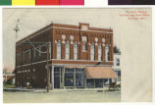 | nico-1139: 03/29/2008: Met David Bushaw, current owner of this building. He is doing an awesome job of restoring the I.O.O.F. meeting hall, as well as the rest of the top floor, and the exterior of the building.My hat goes off to him, and his family, for their obvious passion in restoring a portion of, not only St. Peter's past, or of Minnesota's past, but the entire nation's past, as the I.O.O.F. is one of the largest, and oldest, fraternal orders in the United States.
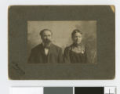 | scott-180: This picture is of my grandparents, Alois & Elizabeth (Koelzer) Wemerskirchen. They lived in Taunton Minnesota (near Minneota) from about 1904 to 1920. They were married in St. Benedict, Scott County in 1877. Alois farmed with his father, Cornelius Wermerskirchen in St. Benedict until the 1890's. He moved to Iona, Minnesota, in 1898, later moving to Taunton.
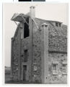 | bsc-2096: This rock barn was built by my Grandfather, Frank Schott (noticed the spelling of his name is wrong on the label).I remember our mother, the youngest of Frank Schott's children, telling us stories about her childhood, included were stories of when it was very hot in the summer, the whole family would sleep up in the hayloft,it was cool up there because of the concrete floor and the breeze would flow through. Our mother would sleep walk at times as a child, and once she woke up just before she stepped off the edge of the hayloft. She was about 11 years old then.
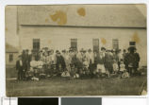 | umc-25: My mother was a member of this church.. her name was Beth Fuller. Her parents were Clayton, and Hattie Fuller. But I can't tell if they are in this picture or not..
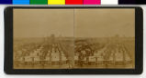 | mpls-602: I think this is Mpls Seed Co Elevator along Hiawatha with Simmons School in background
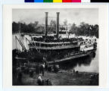 | good-293: My husband's great-grandfather, Gustaf Svensson, a Swedish immigrant, volunteered for the Union Army in 1861 along with many other immigrants from Goodhue County. The volunteers boarded the War Eagle and went up river to Ft. Snelling where they were outfitted for the war. Again they boarded the steam boat and went up river to St. Paul where they marched in precision through the streets and past the cheering crowd. They marched back to the War Eagle, steamed down river to LaCrosse where they boarded a train that took them to Tennessee and the War. Gustaf returned safely to Red Wing in 1864 where he married in Vasa (Goodhue County) and had three sons. He died in 1873 at the age of 48.
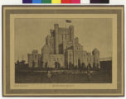 | hill-208: hmm it does not look like a ice palace
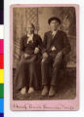 | blue-1714: (Photo credit: G. E. Keene - Mankato, MN - 1890s -- found in Kenneth Carley's "The Dakota War of 1862," (c)2001, ch. 15, p. 82.)Dakota name - WalinyanwasteWhich wife? Snana or Mockpedaga/Sarah? If the above date is correct, one might infer the latter.
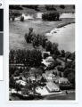 | hzf-57: TEST, TEST! JUST TRYING THIS OUT. I SUSPECT, THAT WITH EDITING, YOU WILL GET SOME HELPFUL AND INTERESTING FEEDBACK ABOUT THE PHOTOS AND HISTORY. I WAS WONDERING, SINCE THIS IS A WIKI, IF I WOULD BE ABLE TO ACCESS IT THROUGH OUR FIREWALLS. SEEMS OKAY! BARB WEINER.
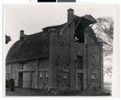 | bsc-2097: Hello, I am the granddaughter of Frank Schott the owner, designer, and builder of this rock barn. I noticed you have his name spelled wrong. His name is Frank Schott. He was an immigrant from Germany. He was a college graduate and a licensed Architect from Germany. You should feature his chicken coop also. It says "Swan Hill" on it. Frank Schott was a Stone Mason and a farmer at Chico Minnesota. He lived to be 84 years old. He had 7 children with his wife Sofie Schott. My mother Rose Anne Schott was the youngest of their children.
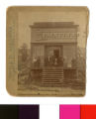 | nemhc-1447: The name should be Hamilton & Hicken. The location probably should be the upper side of Superior St between 5-6AveW (polk 1885 says "Hamilton & Hicken painters ns Sup 3 w of 5AveW". In 1886 they built on 5AveW between Superior St and 1st Street.
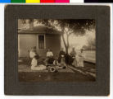 | blue-1663: This photo has so many great elements, and the zoom feature lets you study them all. I wish I were in this scene to hear the conversation. Those women have great stories, I am sure.
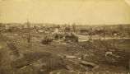 | stbm-301: My great-grandmother, Rose Mohs Steman, survived this tornado. As a three month old baby, she was missing after the tornado destroyed the Mohs family home. As the story goes, my great-great-grandmother Margaret went to the temporary morgue to find Rose. She did - she found Rose among the other dead at the morgue. Thinking Rose was dead, my great-great-grandmother cleaned out Rose's mouth. Rose began to suck her finger - was alive! Rose lived a long life, passing away in 1975.
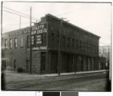 | nemhc-2394: This bldg is located 302-08 Lake Ave S in Duluth. Bldg plans by Traphagen 1889 for Clyde Iron. "Duluth Showcase leased the building formerly occupied by Clyde (Herald 4/18/1908)."
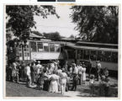 | msn-440: Rhonda,This particular crash happened in 1951 on 42nd Ave. S. in Minneapolis. Where was the crash that killed your granfather?
 | msn-440: Was this picture taken in 1954. My Grandfaher Evan Simmons was killed in a street car accident that occured on oct 31st 1944. Could this be the same.
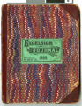 | mpls-3277: Is there an error in the name of this portion of Ezra's diary? Wasn't he 21 in 1889 rather than 14? Did I miss something?
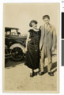 | swede-13: At last I have a seen a photograph of the famous Scandinavian Vaudeville performer "Ole From Laughtersville" whom my relatives saw onstage at Dania Hall on Cedar Avenue in the early 1900s.He brought a lot of happiness to people.
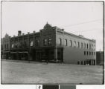 | nemhc-2559: Typo, should be 102-108 E Superior. (The new Astoria Hotel billiard hall and buffet cor 1AveE Sup will be formally opened tomorrow . . Martin Smith prop. The Astoria 100ft frontage . . 115 ft deep . . bldg is brick, erected at cost of $45000 . . 56 rooms. Herald 3-23-1906.) Picture magnified shows Poirier(awnings, tents)in the 106 E Sup location, and Burg(bar supply) in the 108 E Superior location
 | mhs-1192: What a wonderful resource! I was able to go directly to the Carver County page using the index on the left side, which is what I was looking for information on. This historical atlas is a boon for history research!
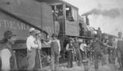 | irrc-1662: Note, if you find XML hard to read, you can also find the aid Steve mentions as a regular web page at http://www.mnhs.org/library/findaids/00493.html.
 | irrc-1662: More information on the Winston Dear Company can be found at the Minnesota Historical Society. The finding aid for the Adams Family Mining Companies has several files relating to correspondence, memos, conversations and records between the Adams Companies and the Winston Dear Company. The finding aid can be found online at: http://www.mnhs.org/library/findaids/00493.xml.
 | stearns-389: Thank you for posting plat books on Minnesota Reflections. They are so helpful in establishing land ownership. They are fun to search, too.
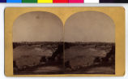 | mpls-666: I do not believe this is the Fort Snelling Bridge - the stone supports are taller in the other photos I have seen. Further more the buildings behind it look far too tall to be any of the buildings at the fort.
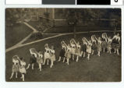 | npa-8: Another resource for Czech/Slovak Minnesota historical photos could be the Czech & Slovak Sokol Minnesota: http://www.sokolmn.org/
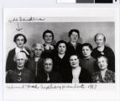 | jhs-334: The woman on the far left in the front row is Sophie Gordon, wife of Dr/ George J. Gordon, founder of the Talmud Torah
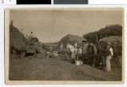 | olms-713: Wow. Claus Dubbels is the brother of my great-great-grandfather, Johann Dubbels. H.H. Bierbaum, I believe, was Johann's brother-in-law. (Mary Bierbaum was the first child of European ancestry born in Viola, Olmstead County)and the Stickforts were his mother-in-law's family. How amazing to pop a name into a search engine and come up with a photo from their lives of a long-lost time. That's absolutely wonderful. By the way, our records say Claus lived to 104.
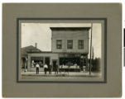 | swede-50: What a wonderful photo from a bygone era. Keep it on your website.Its fascinating the detail that can be brought up on screen.Its a gem. Wonder what other treasures from the late 1800s and early 1900s from South Minneapolis are found in your files, would be interesting to browse.Scandinavian history of the common people in South Minneapolis is a special interest of mine .Thank You so much.
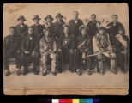 | becker-32: "Specific subject" does not include standardized or culturally-appropriate term for Anishinaabe people (some entries use Chippewa or Ojibwa or Ojibway or Ojibwe); none of the men are identified individually -- something that might be able to happen with more communication between historical societies and Minnesotan Indigenous governments
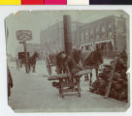 | good-235: This photo might be a good entre into questions of child labor, wood as a vital energy commodity, sidewalk activities, as in what else did people do on sidewalks?
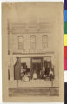 | nico-1159: This is a beautiful picture that I, as a Rinkel, would like to possess and add to one of my genealogy files, but that is probably impossible. I live in the Netherlands and, as far as I know, I am not a family member of these Rinkels. Do you have more info about this family?My zip code in the Netherlands is 2923GD-1. E-mail a.rinkel(at)versatel.nl
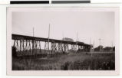 | msn-19: According to my father, on the east side of the bridge facing west. The large building in the background is the old Minneapolis Moline plant. The streetcar line would descend to the front of the Minneapolis Moline offices and turn on 9th Avenue. Excelsior Boulevard did not exist, only a dirt road called Sewer Pipe road named and used by the local people to get to Glen Lake.

